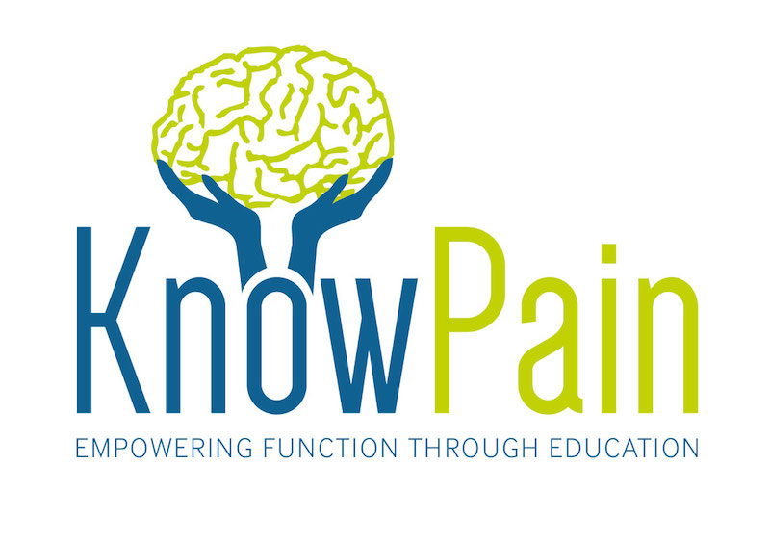

Pain demands an explanation. The challenge of successfully overcoming pain can be one of the most daunting for both clinicians and patients.

Know Pain courses have provided a wide range of clinicians around the world with practical pain education skills. Feedback from over 500 healthcare professionals found that 100% would recommend a Know Pain course to their colleagues. 95% strongly agreed that Know Pain CPD had equipped them with practical skills to help people in pain.

Course Description:

The challenge of successfully managing persistent pain can be one of the most daunting for both clinicians and people in pain who are often frustrated after failed short-term interventions. It is difficult to understand and explain high and prolonged levels of pain where a traditional tissue based cause is lacking. This course explores a cutting edge, patient centered approach using a variety of practical learning methods to help your patients understand their pain. It provides a range of practical applications and methods to take into your clinic and immediately apply with your patients. The course content blends a wide range of contemporary evidence from both educational and healthcare literature.

Course Outline:

This 2-day workshop is relevant to anyone who works with people in pain. It uses evidence-based educational methods to explore therapeutic neuroscience education from both clinical and educational perspectives. You will also learn how to apply these teaching skills within your practice setting. Patient education forms a significant component of modern healthcare, yet most clinicians have a limited toolkit. To educate people about their pain, we must first learn to teach.

Know Pain Courses coming soon

May 14th / 15th Spire St Anthony Hospital, North Cheam, Surrey
June 28th / 29th Bath and NE Somerset Council Chambers,
July 9th / 10th St Peter’s Hospital, Chertsey, Surrey
July 16th/17th Burnley Hospital
July 21st/22nd Hyde, Cheshire
August 20th / 21st Royal Bournemouth Hospital, Dorset
September 10th / 11th Tom Astley Physiotherapy, Finsbury Park, London
October 1st / 2nd Life Well Fitness, Falkirk, Scotland
November 19th/20th Peterborough Hospital

Visit www.knowpain.co.uk for more details

Special Promotions!
20% discount for multiple bookings of 2 or more people.
20% discount for students

Email mike@knowpain.co.uk

@knowpainmike
knowpainmike

